**Windows Azure Table Storage**

**Step 1:** Select Storage from Windows Azure Management Portal & click on “Create New”

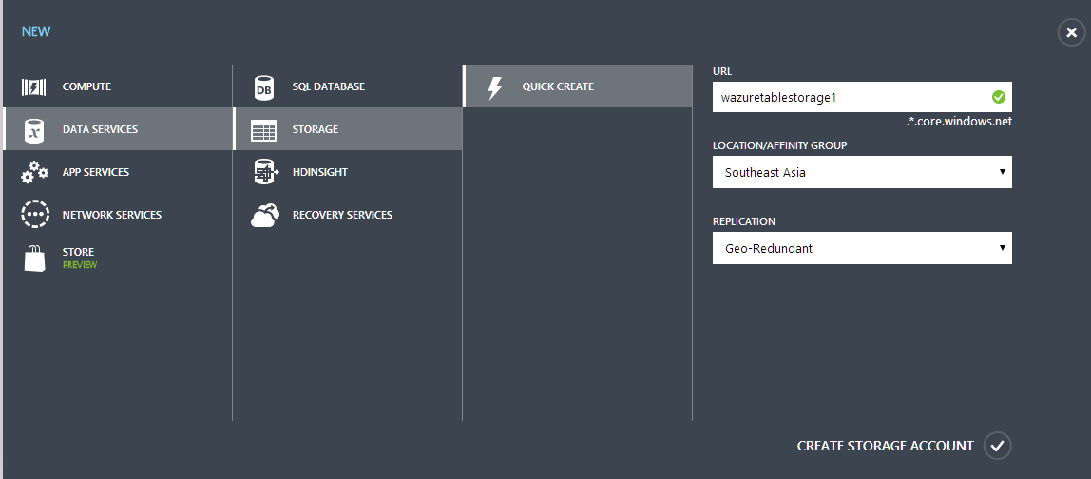

**Step 2:**

After creating Storage, Create New Website from Visual Studio. Add one page.

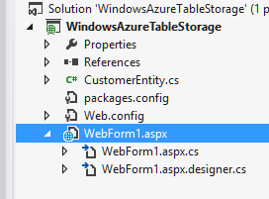

**Step 3:** Right click on the references and select “Manage NuGet Packages…”

Enter the term for search “Windows Azure Storage”

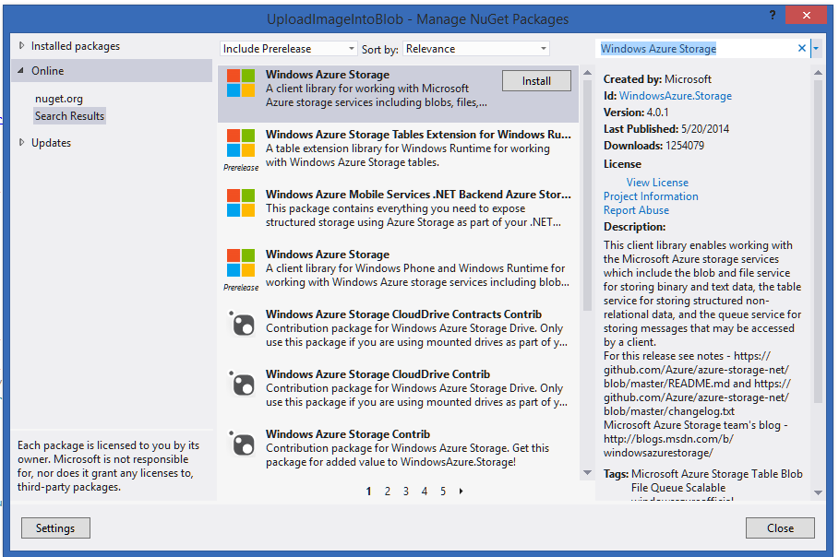

**Step 4:** Open page for design the website according to Table Storage.

<html xmlns="http://www.w3.org/1999/xhtml">

<head runat="server">

<title></title>

</head>

<body>

<form id="form1" runat="server">

<div>

First Name:

<asp:TextBox ID="txtFirstName" runat="server" />

<br />

Last Name:

<asp:TextBox ID="txtLastName" runat="server" />

<br />

EMail:

<asp:TextBox ID="txtEmail" runat="server" />

<br />

Phone:

<asp:TextBox ID="txtPhone" runat="server" />

<br />

<asp:Button ID="txtInsert" Text="Insert" runat="server" OnClick="txtInsert_Click" />

</div>

</form>

</body>

</html>

**Step 5:** Open Program.cs file

First add references for Windows Azure Storage

using Microsoft.WindowsAzure;

using Microsoft.WindowsAzure.Storage;

using Microsoft.WindowsAzure.Storage.Auth;

using Microsoft.WindowsAzure.Storage.Table;

namespace WindowsAzureTableStorage

{

public partial class WebForm1 : System.Web.UI.Page

{

protected void Page_Load(object sender, EventArgs e)

{

}

protected void txtInsert_Click(object sender, EventArgs e)

{

// Retrieve the storage account from the connection string.

CloudStorageAccount storageAccount = new CloudStorageAccount(

new StorageCredentials("storagename",

"storageaccesskey"), true);

// Create the table client.

CloudTableClient tableClient = storageAccount.CreateCloudTableClient();

**// Manually Create peopledata Table using Azure Storage Explorer**

// Create the CloudTable object that represents the "people" table.

CloudTable table = tableClient.GetTableReference("peopledata");

// Create a new customer entity.

CustomerEntity customer1 = new CustomerEntity(txtLastName.Text, txtFirstName.Text);

customer1.Email = txtEmail.Text;

customer1.PhoneNumber = txtPhone.Text;

// Create the TableOperation that inserts the customer entity.

TableOperation insertOperation = TableOperation.Insert(customer1);

// Execute the insert operation.

table.Execute(insertOperation);

}

}

}

**Step 6:** Create one class name it as CustomerEntity.cs

Add reference

using Microsoft.WindowsAzure.Storage.Table;

namespace WindowsAzureTableStorage

{

public class CustomerEntity : TableEntity

{

public CustomerEntity(string lastName, string firstName)

{

this.PartitionKey = lastName;

this.RowKey = firstName;

}

public CustomerEntity() { }

public string Email { get; set; }

public string PhoneNumber { get; set; }

}

}

**Step 7:** now run the website

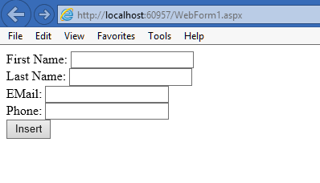

Enter the data

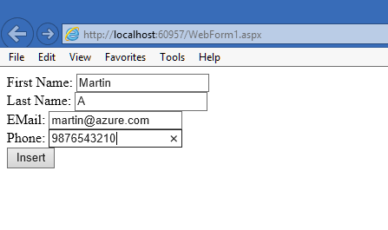

For view the data run the “Azure Storage Explorer” tool.

Add the storage account name & access key

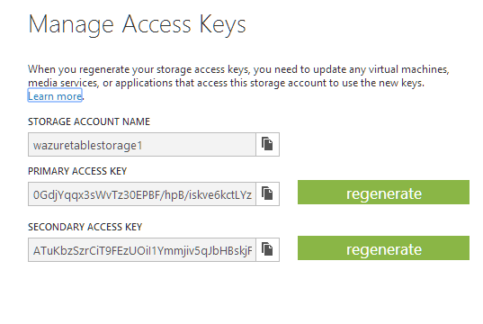

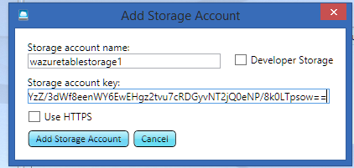

After entering the credentials below window will open

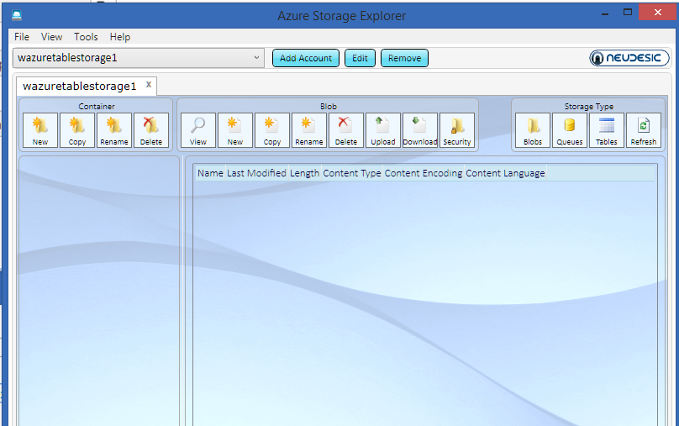

Then click on the “Tables” & at the left side generated table will display.

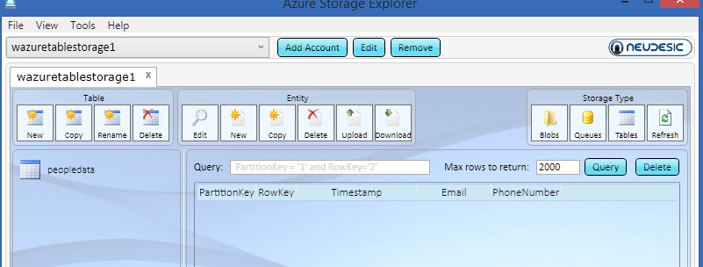

Select table name & click on Query button

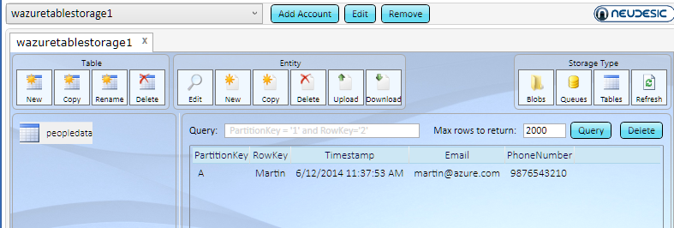

Also there are another method to view the data using Windows Azure with Visual Studio feature.

Sign in with Windows Azure Credentials in Visual Studio & open Server Explorer

